Facilitators’ Guide: “PRACTICUM - Mini Projects”

- Presentation on Mini-Projects and Group Activity

(105 minutes)
Session Overview: This session aims to support participants on why a mini-project is needed, things to do for a mini-project, necessary preparations, and for participants to apply knowledge and skills developed from other modules, such as basic IT skills, data analysis & visualization, and quality improvement, by developing a mini project for implementation in their respective PHC facilities, relevant to PHC performance. There session also have full group and breakout group activities.

Logistics/Time Breakdown
Total time – 105 minutes
1. Presentation 45 minutes
2. Group activity 30 minutes
3. Breakout Group activities 30 minutes

Materials Checklist
• Projector and screen
• Laptops
• Open space/meeting room
• Microsoft Office Suite (Word, Excel & PPT)

Learning Objectives and Skills
By the end of this session, participants should be able to
- Design a mini-project to apply one or more of the skills learned during the course.
- Develop the key objectives and learning outcomes for the mini project
- Identify the key skill topics to cover, the scope of the mini project,
- Plan the key tasks to prepare for the mini-project, including key logistics

Session Content
1. Presentation (45 minutes)
The presentation will highlight key areas such as:
- Objectives of the Practicum and Mini-project
- The potential mini-projects
- Objectives and outputs of the potential Mini-projects
- Group Discussions and Breakout group activities (on the worksheets).
• Discussion around the schedule and task breakdown for the overall work, including time allocations for group-based activities.
• The need to plan a checklist of tasks and activities to prepare for and implement the mini-project. Sample planning templates will be shared with participants for ease of learning.

2. Group Discussions and Breakout Group Activities (60 minutes)
Using a simple template or worksheet, participants will work in small groups to conceptualize a hypothetical mini-project to undertake and identify all the relevant materials and resources needed to design and execute this. The group discussions and breakout group activities will also be used as an opportunity to select the facilities for the practicum. To do this, there will be organized group activities. A group lead should be chosen to guide discussions, whilst another is assigned as a rapporteur.
Facilitators will split the participants into breakup groups after whole group discussion. A facilitator will be assigned to each group and direct them on how to work around the contents of the worksheet.The facilitators will begin by explaining the objectives of the group discussion and breakout group activities. All groups will reconvene in the training room to present completed worksheet contents.

Note to facilitators: Depending on the readiness of the group, rather than preparing a hypothetical mini-project by the group, the facilitators can suggest that the participants work individually or in small groups to conceptualize and plan the mini-project they would like to implement, and therefore complete the worksheet for said mini-projects.
Facilitation support
During the group activities, facilitators need to visit each group and provide guidance and support when necessary. Questions arising from the group activities may be clarified, and any additional support provided to any group where necessary.
Expected output
At the end of the group activities, it is expected that a mini-project will be conceptualized relevant to individual group topic, objectives, as well as the selected facilities and levels of healthcare, along with the logistics needed to undertake the activity.

Planning for Mini-Project Worksheet
- Mini-project Name:
- Skill challenges/gaps to be addressed:
- Skills to be implemented:
- Learning Objectives:

Sample Planning Spreadsheet:
Activities Required Start Date 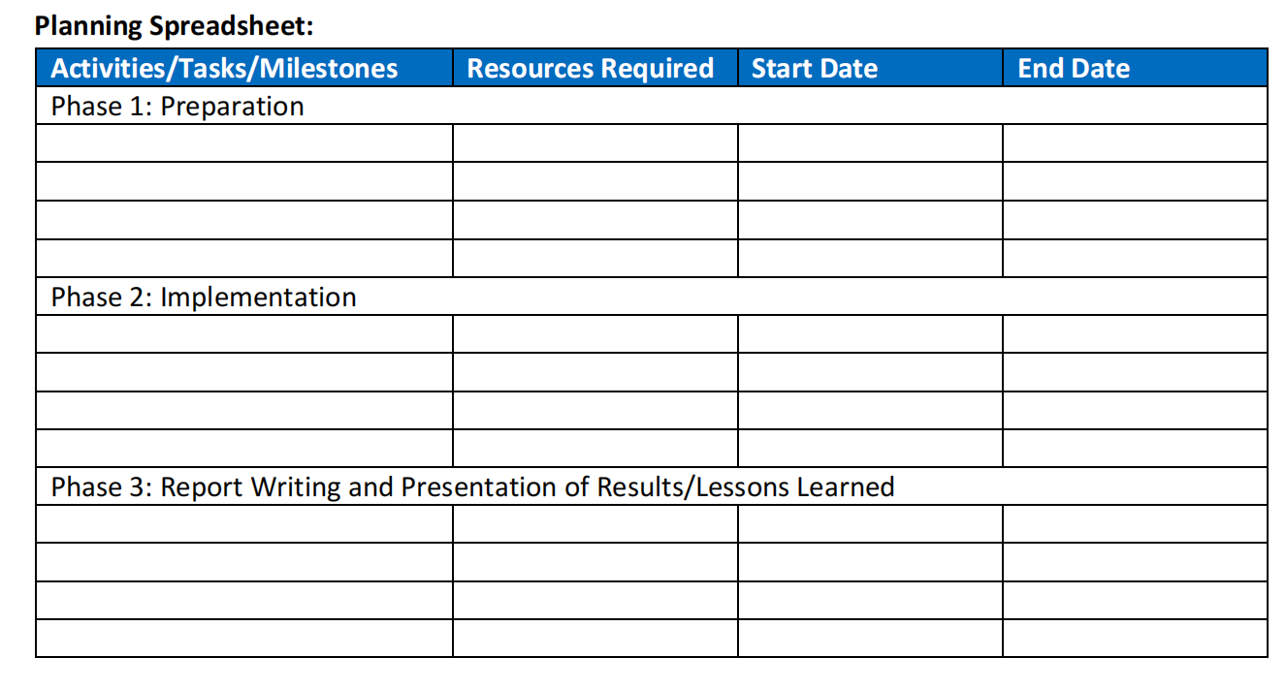
- Guidance on Data Collection and Analysis for Mini-Projects
(75 minutes)
Session Overview: This session introduces participants to data collection and analysis to
support the implementation of the mini-projects. This is to help participants understand the type of data collection approach(s) to adopt in the gathering of evidence. This is also
dependent on the type and nature of evidence to be gathered. This is a critical step in the
facility data collection period.
Learning Objectives and Skills
Participants should be asked to deliberate and share their thoughts on the learning objectives for this session. The discussion should explore how the data will be collected, the type and nature of data to be collected, whether data will be collected from a single or multiple facilities, and the skills needed to be able to collect the data. Participants should also be taken through the data analysis processes, the type of analysis to be done and how this will be reported or presented.

Logistics/Time Breakdown
Total time – 75 minutes
1. Presentation: 15 Minutes.
2. Group Discussions and Breakout Group Activities: 60 Minutes.
Materials Checklist
Here, participants in addition to completing part 2 of the worksheet, need to deliberate on the key materials and logistics needed and these may include
- Computers or laptops, Excel or a free account on Qualtrics
- Digital audio recorders & Tablets.
Session Content
1. Presentation (15 min.): The focus will be on the following:
• Clearly define approaches to sourcing data and information for the mini-project: (i) collecting data from secondary sources or information sources, such as available HMIS and other data bases, or facility reports and dashboards. Other approaches may be primary sources such as Key Performance Indicators/In-Depth Interviews, Observation, Survey, Questionnaires or Process Mapping.
• Review of the tasks related to data collection, instrument design (for primary data), unit of analysis (facilities, nurses, patients, etc.) and sample size or volume of observations needed for the mini-project.
• (If primary data is be collected from facilities). Review of tasks related to the
selection of PHC facilities or informants to be interviewed and type and nature of
data to be collected. Facility selection and entry may require the need to follow protocols and procedures, and these must be adhered to.
• Considerations of the time required to collect and analyze the data, and prepare the
final report.
Note to facilitators: the objectives of the full group discussions and breakout group activities in this session are: 1) for participants to understand and complete the elements of part 2 of the worksheet, and 2) present a complete worksheet for discussions on concerns and issuers arising from breakout group activities. Following full group discussions, facilitators are to divide the participants into groups (3) with 4 participants from the same county or administrative division (there are 3 counties represented at each training region). A Walk through of the worksheet template will be helpful for participants. You can print out the PowerPoint presentations from the earlier module on data analysis, QI and data communication for consultation while completing the worksheet template.

2. Small Group (60 minutes)
Participants should be divided into three (3) groups of four to complete the worksheet to
prepare the assigned or re-designed mini-projects.
• Selected data based on your mini-project, either via available databases, survey or
KPIs, as this depends on the nature and type of mini-project.
• Short description of data analysis
• Sample size
• Identification of any analysis and visualization tools

Note to facilitators: Depending on the readiness of the group, rather than preparing a
hypothetical mini-project by the group, the facilitators can suggest that the participants work individually or in small groups to complete the worksheet for their mini-projects.
Expected output
A well-developed methodological framework outlining the data collection techniques, the
participants, the type and nature of data to be collected, and the location for data collection and completed work sheet.

- Presentation of Mini-Project and Implementation Plan
(90 minutes)
Session Overview: This session will see each individual or a pair make a presentation highlighting their mini-project and their findings. In these presentations, they will share implementation methodologies, KPIs to be considered, key insights, lessons learned, challenges, and overall experience from the implemented mini project.
Session Content
1. Group presentations of major elements of mini-project proposal (15 minutes
per proposal, 3 groups)
• Title
• Rationale
• Objectives
• Source of data/information
• Anticipated results
• Timeline: the timeline for the implementation of Mini-projects should fall with in a time frame of one (1) Month after the pilot training.
2. Q&A: Share feedback and identify areas for improvement (10 minutes per proposal)
3. Facilitator Wrap-up Analysis (5 minutes)
At the end of the group’s presentation, the facilitators will provide feedback for each of the groups and overall/general feedback, noting commonalities and diversity in the mini-projects. Key gaps and strengths of the overall work will be shared. All presentations will be collated and stored in a single point in the e-library for reference, learning.
Course Facilitators will need to provide instructions on:
- Due dates of mini-project reports
- Tentative dates of (short) virtual mini-project presentations to the entire group
- Solicit support from Aceso Global for a completed M&E instruments
- Availability of facilitators to provide virtual support to participants on mini-project
- Implementation.

- M&E Plan

The M&E Plan for Practicum consists of:

- Assessment (reviewing participant feedback, training effectiveness, and skills acquisition).

- Documentation (of training impact, skill improvements, and performance enhancements in PHC management).

- Qualitative feedback (interviews and surveys with participants).

Examples of KPIs to consider

- Increased data utilization;

- Improved decision-making;

- Enhanced service delivery will be monitored and documented.

